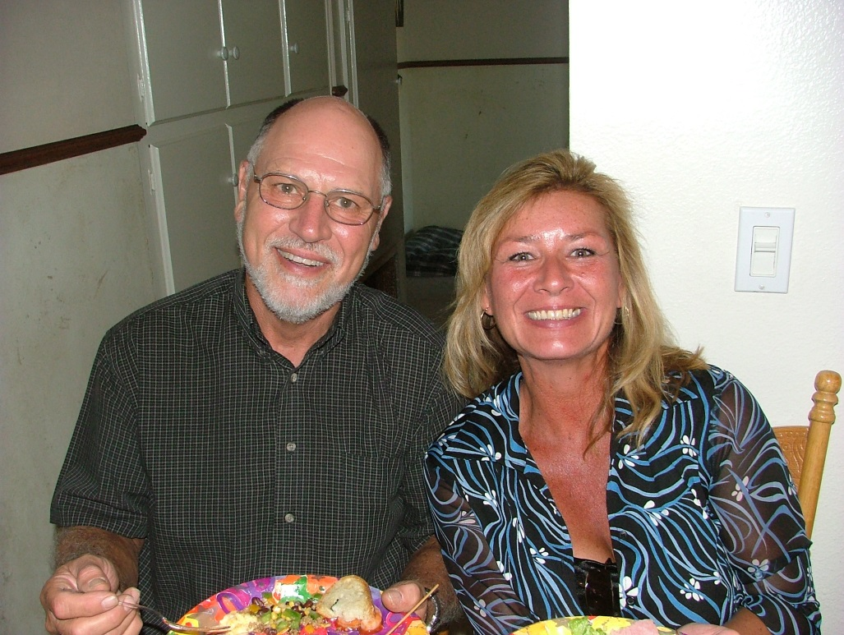

John and wife, Tamey Wolfe – 2004

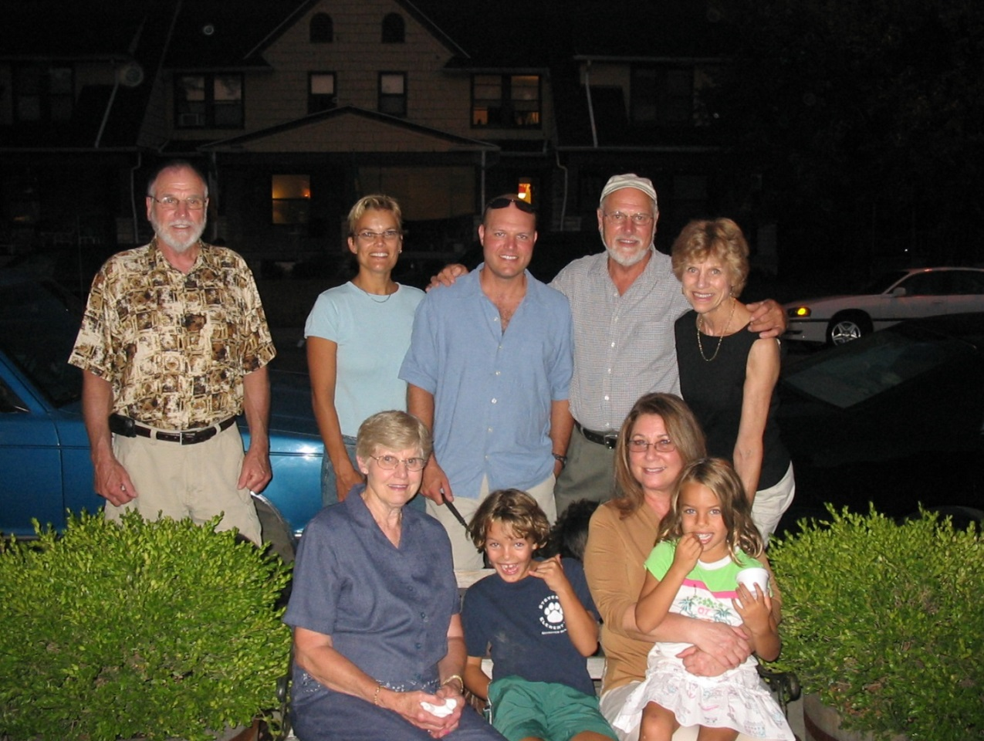

Standing: Nelson, Laura, Tyler, John, Mary Jo

Seated: Lois, Eryn, Sandy & Leah - 2006